
MAJOR PROJECT REPORT
ON
“BLOCKCHAIN-ENABLED MULTI-BIOMETRIC AUTHENTICATION SYSTEM USING AI/ML”
Submitted To
Department of Digital Forensic & Cyber Security
National Forensic Sciences University
For partial fulfilment for the award of degree
B.Tech - M.Tech
In
Computer Science & Engineering (Cyber Security)
Submitted By
Jadav Madhavkumar h.
102CTBMCS2122013

Under the Supervision of
Dr. Archana Patel
Department of Law, Forensic Justice and Policy Studies
National Forensic Sciences University,
Delhi Campus, New Delhi – 110085, India
December 2025


DECLARATION
I hereby declare that the thesis entitled “BLOCKCHAIN-ENABLED MULTI-BIOMETRIC AUTHENTICATION SYSTEM USING AI/ML” is a research work done by me and no part of the thesis has been presented earlier and will be presented for any degree, diploma or similar title at any other institute/university.

Jadav Madhavkumar h.
102CTBMCS2122013
B.Tech - M.Tech CSE (cyber security)
Year of Passing: 2026

Date: 19/12/2025
Place: Delhi Campus



ORIGNALITY REPORT CERTIFICATE

I certify that

a. The work contained in the dissertation is original and has been done by myself under the supervision of my supervisor.
b. The work has not been submitted to any other Institute for any degree or diploma.
c. I have conformed to the norms and guidelines given in the Ethical Code of Conduct of the Institute.
d. Whenever I have used materials (data, theoretical analysis, and text) from other sources, I have given due credit to them by citing them in the text of the dissertation and giving their details in the references.
e. Whenever I have quoted written materials from other sources and due credit is given to the sources by citing them.
f. From the plagiarism test, it is found that the similarity index of whole dissertation within 10% and single paper is less than 10 % as per the university guidelines.

Jadav Madhavkumar h.
Enroll. No.: 102CTBMCS2122013
Date:
Place: Delhi Campus

Forwarded by

(Dr. Archana Patel)

Date: 19/12/2025


CERTIFICATE

This is to certify that the work contained in the dissertation entitled “BLOCKCHAIN-ENABLED MULTI-BIOMETRIC AUTHENTICATION SYSTEM USING AI/ML”, submitted by Jadav Madhavkumar h. (Enroll. No.: 102CTBMCS2122013) for the award of the degree of B.Tech M.Tech Computer Science & Engineering (Cyber Security) to the National Forensic Sciences University, Delhi Campus, to the National Forensic Sciences University, Delhi Campus, is a record of bonafide research works carried out by him/her under my supervision and guidance.

Dr. Archana Patel
Assistant Professor
Department of Cyber Security
and Digital Forensics
National Forensic Sciences University
Delhi Campus, Delhi, India
Date: 19/12/2025
Place: Delhi Campus

ACKNOWLEDGEMENT

Write an acknowledgement for maximum of one page. The candidate should convey his appreciation to all whom have played a role for completion of his dissertation work. The supervisor, supervisor, head of the department, faculty members, lab mates etc may be acknowledged. Any controversial statement or non-academic/abused sentiments are not allowed to write in this page.

With Sincere Regards,
Jadav Madhavkumar h.
102CTBMCS2122013
B.Tech - M.Tech CSE (cyber security)
Year of Passing: - 2026

TABLE OF CONTENTS
Abbreviations |  |  |  | V
List of Tables |  |  |  | VI
List of Figures |  |  |  | VII
List of Screenshots |  |  |  | VIII
List of Symbols |  |  |  | IX
ABSTRACT

I Understanding the Crisis and Building
the Foundations
Chapter 1. | The Crisis of Digital Identity in  the Modern Age
 | 1.1 | The Great Authentication Paradox: Putting Your Trust in the Untrustworthy
 | 1.2 | The Catastrophic Consequences: When Identity Becomes a Commodity
 | 1.3 | The Flaw of Centralized Authority: A “Single Point of Failure”
 | 1.4 | Biometrics: The Promise and the Pitfall
 | 1.5 | Towards a New Paradigm: The Rise of Self Sovereign Identity (SSI)
 | 1.6 | The Next Generation of Authentication: Our Vision
Chapter 2. | Foundations of Trust: Blockchain  and Decentralised Ledgers
 | 2.1 | Beyond Buzzwords: What is Blockchain, Really?
 | 2.2 | The Pillars of Trust: Core Properties of Blockchain
 | 2.3 | Orchestrating Agreement: Blockchain Consensus Mechanisms
 | 2.4 | The Code of Trust: Smart Contracts
 | 2.5 | Why Blockchain is Indispensable for Secure and Auditable Identity
 | 2.6 | Public vs. Permissioned Blockchains: Choosing the Right Foundation
Chapter 3. | The Power of You: Multi-  Biometrics and Intelligent Authentication
 | 3.1 | The Human Signature: A Foundation in Biometric Identity
 |  | 3.1.1 | Defining Biometrics: From Measurement to Authentication
 |  | 3.1.2 | The Spectrum of Biometric Modalities: Physiological vs. Behavioural
 |  | 3.1.3 | Inherent Vulnerabilities: Noisy Data and Non-Universality
 |  | 3.1.4 | The Hazards of Spoofing and Presentation Attacks
 | 3.2 | The Synergy of Self: The Strategic Advantage of Multi-Biometrics
 |  | 3.2.1 | A Multi-Layered Defence: Enhanced Security and Robustness
 |  | 3.2.2 | Overcoming Unimodal Challenges: Accuracy, Reliability, and User Experience .
 |  | 3.2.3 | The Economic and Operational Case for Multimodal Systems
 | 3.3 | The Intelligent Architectures of Fusion: A Technical Deep Dive
 |  | 3.3.1 | Sensor-Level Fusion
 |  | 3.3.2 | Feature-Level Fusion
 |  | 3.3.3 | Score-Level Fusion
 |  | 3.3.4 | Decision-Level Fusion
 | 3.4 | The Neural Revolution: AI/ML as the Engine of Intelligent Authentication
 |  | 3.4.1 | The Foundation: Machine Learning in Biometrics
 |  | 3.4.2 | Deep Learning for Feature Extraction and Pattern Recognition
 | 3.5 | The Unblinking Eye: The Vital Mechanism of Liveness Detection
 |  | 3.5.1 | What is Liveness Detection and Why Is It Revolutionary?
 |  | 3.5.2 | Active Liveness Detection: User-Centric Security
 |  | 3.5.3 | Passive Liveness Detection: The Seamless Experience
 |  | 3.5.4 | Hybrid Models
 | 3.6 | Real-World Implementation and The Path Forward
 |  | 3.6.1 | Case Studies in Banking and Healthcare
 |  | 3.6.2 | Ethical Considerations: Privacy, Data Security, and Regulation
Chapter 4. | Designing the Decentralized  Multi-Biometric Identity System  (DMIDS)
 | 4.1 | Introduction: A Paradigm Shift in Digital Identity
 | 4.2 | High-Level Architecture Overview
 | 4.3 | Component Roles and Interactions
 | 4.4 | Digital Identity Lifecycle
 |  | 4.4.1 | Enrolment and Issuance
 |  | 4.4.2 | Verification and Authentication
 |  | 4.4.3 | Ongoing Management and Revocation
 | 4.5 | Data Strategy: On-Chain versus Off-Chain Design
 |  | 4.5.1 | Why Biometrics Must Stay Off-Chain
 |  | 4.5.2 | On-Chain: Immutable Proof Anchoring
 | 4.6 | Performance and Scalability
 | 4.7 | Trust Models in a Decentralized Identity System
 |  | 4.7.1 | Triangle of Trust: Issuer–Holder–Verifier
 |  | 4.7.2 | DIDs and VCs
 |  | 4.7.3 | Zero-Knowledge Proofs (ZKPs)
Chapter 5. | Cryptographic Engineering for  Ultimate Privacy and Security
 | 5.1 | The Foundation of Trustless Verification: Merkle Trees
 |  | 5.1.1 | Merkle Proofs: Enabling Lightweight and Private Verification
 |  | 5.1.2 | Real-World Applications and Engineering Context
 |  | 5.1.3 | Engineering Challenges and Advanced Architectures
 | 5.2 | Proving Without Revealing: The Paradigm of Zero-Knowledge Proofs (ZKPs)
II. Architecting, Developing, and
Deploying the Next-Gen Identity
System
Chapter 6. | Development of Designing the Decentralized  Multi-Biometric Identity System  (DMID)
 | 6.1 | Introduction
 | 6.2 | System Architecture
 | 6.3 | Diagram: DMID IoT Hardware Integration
 | 6.4 | Implementation: Rust Firmware Sample
 | 6.5 | Deployment Considerations
Chapter 7. | Cryptographic Engineering for  Ultimate Privacy and Security
 | 7.1 | Cryptography as the Foundation of DMID Trust
 | 7.2 | Biometric Template Transformation and Hashing
 |  | 7.2.1 | Non-Reversible Hashing (SHA-256
 | 7.3 | Zero-Knowledge Proofs (ZKPs) for Authentication
 | 7.4 | Hardware Security and Acceleration on ESP32- S3
 |  | 7.4.1 | Dedicated Cryptographic Accelerators
 |  | 7.4.2 | Secure Boot and Flash Encryption
 | 7.5 | Code Integrity with Rust and Compile-Time Checks
Chapter 8. | Intelligent Architectures of Fusion: A Technical Deep Dive
 | 8.1 | The Imperative for Fusion at the Edge
 | 8.2 | Feature-Level Fusion vs. Score-Level Fusion
 |  | 8.2.1 | Score-Level Fusion (Rejected)
 |  | 8.2.1 | Feature-Level Fusion (Adopted Strategy)
 | 8.3 | The Role of the ESP32-S3’s PSRAM in Fusion
 | 8.4 | Neural Network Design for Embedded Fusion
 |  | 8.4.1 | Model Optimization
Chapter 9. | The Neural Revolution: AI/ML  as the Engine of Intelligent Authentication
 |  | 9.1 The Centrality of AI/ML in DMID
 |  | 9.2 Deep Learning for Facial Feature Extraction
 |  | 9.3 Intelligent Extraction from Fingerprint Data
 |  | 9.4 The Training Mandate: Maximizing InterClass Variance
Chapter 10. | The Unblinking Eye: The Crucial  Role of Liveness Detection
 | 10.1 | The Threat of Presentation Attacks
 | 10.2 | Layered Liveness Detection in DMID
 | 10.3 | Tactile Liveness Detection for Fingerprints
 | 10.4 | Liveness Aggregation and Final Authentication Gate
Chapter 11. | Real-World Implementation and  The Path Forward
 | 11.1 | Hardware Assembly and PCB Integration
 | 11.2 | Firmware Development and Real-Time OS
Chapter 12. | User Experience and Accessibility in Digital Identity
 | 12.1 | The UX Imperative: Balancing Security and Usability
 | 12.2 | Optimization for Seamless Interaction
 | 12.3 | Accessibility Considerations
Chapter 13. | Interoperability and Standards:  Bridging Identity Silos
 | 13.1 | The Need for Identity Interoperability
 | 13.2 | W3C Decentralized Identifiers (DIDs)
 | 13.3 | Verifiable Credentials (VCs)
 | 13.4 | Standards for Embedded Communication
Chapter 14. | Data Strategy: The On-Chain vs.  Off-Chain Paradigm
 | 14.1 | Principle of Data Segregation: Privacy by Design
 | 14.2 | Off-Chain Data: The Secure Edge Enclave
 | 14.3 | On-Chain Data: Immutable Proofs and References
 | 14.4 | Data Integrity and Chain of Custody
Chapter 15. | Addressing Scalability and Performance Challenges
 | 15.1 | Scalability Imperatives for Decentralized IoT
 | 15.2 | Edge-Centric Performance Optimization
 | 15.3 | Failure Resilience and High Availability
Chapter 16. | Trust Models in a Decentralized  Environment
 | 16.1 | The Paradigm Shift from Centralized Authority
 | 16.2 | Trust Delegation via Verifiable Credentials (VCs)

LIST OF ABBREVIATIONS

Abbreviations should be alphabetically written

Abbreviation | Description
AAA | Authentication, Authorization, and Accounting
AI/ML | Artificial Intelligence / Machine Learning
BLE | Bluetooth Low Energy
CA | Centralized Authority
CIA | Confidentiality, Integrity, & Availability
CNN | Convolutional Neural Network
DID | Decentralized Identifier
DMID | Decentralized Multi-Biometric Identity
ECU | Edge Capture Unit
ECC | Elliptic Curve Cryptography
EMI | Electromagnetic Interference
FAR | False Acceptance Rate
FNN | Fusion Neural Network
FRR | False Rejection Rate
IoT | Internet of Things
MQTT | Message Queuing Telemetry Transport
OTA | Over-The-Air
PII | Personally Identifiable Information
PMU | Power Management Unit
PSRAM | Pseudo-static Random-Access Memory
PCB | Printed Circuit Board
SSI | Self-Sovereign Identity
SSS | Shamir’s Secret Sharing
TLS/SSL | Transport Layer Security / Secure Sockets Layer
PS | Transactions Per Second
VC | Verifiable Credential
VP | Verifiable Presentation
W3C | World Wide Web Consortium
ZKP | Zero-Knowledge Proof

LIST OF FIGURES

Fig No | Figure Description | Page No
Figure 3.1 | Implementation diagram
Figure 4.1 | Work flow
Figure 6.1 | Hardware Integration Diagram for DMID Edge Node
Figure 11.1 | Hardware work Flow + Connection

LIST OF SYMBOLS

ABSTRACT

The need for scalable, secure, and user-friendly authentication methods that go beyond the constraints of traditional password or single-factor methods has increased due to the rapid digitization of services.

In order to provide a strong, impenetrable identity verification framework, this project suggests a Blockchain-Enabled Multi-Biometric Authentication System that makes use of distributed ledger technology and AI/ML-driven decision models. By merging multiple biometric such as fingerprint, iris and other physical characteristics that proved advantages to legal and government with these issues
The system ensures trust while giving suitable environment that with multi-layered trust also give mitigating the risks of spoofing, platform initialize with Decentralized Identifier (DID) that for all biometrics

Part I

Understanding the Crisis and Building
the Foundations

- The Crisis of Digital Identity in the Modern Age

1.1 The Great Authentication Paradox: Putting Your Trust in the Untrustworthy
The tools that we currently have available to help identify ourselves in a secure way the use of passwords, PIN numbers, and one-time codes have proven to be the weakest link in the entire process of establishing secure connections, even after years of promising more seamless ways to communicate using technology. Currently, these technologies are essential for not only global commerce, but also for healthcare and banking, due in large part because they were developed at a time when the level of risk in using these technologies was low.
The Password Problem
The Weakness of Humanity: Those who take risky shortcuts such as writing secure passwords down in unsafe places; creating easy to guess combinations; & re-using passwords across different web sites make it very difficult for many to remember Strong Passwords.

The Phishing Plague: Hackers are currently using Phishing (the art of Social Engineering) and similar forms, to access our computer systems by convincing us into willingly providing our User ID and password.

Credential Stuffing: After a hacker compromises a system, they then typically compare billions of passwords from other secured systems & services to take advantage of how most of us re-use passwords. The Secondary Methods of Security Are Weak
PIN & Secret Questions: PINs can be viewed over some ones shoulder or made up on the spot; & "secret questions" can easily be identified & are likely to be known to others via the Internet.

One Time Passwords: OTPs have their own security issues; like when a hacker creates a SIM Swap attack & gains access to your cellphone number to intercept and return your Authentication Codes back to himself.

1.2 The Catastrophic Consequences: When Identity Becomes a Commodity
Inadequate methods for authentication turn private information into a commodity for illegal conduct. In addition to costing corporations money, breaches disrupt people's lives and give rise to a murky marketplace where anyone may marketplace their identities.

- Escalating Data Breaches: Over the past ten years, significant instances like Yahoo and Equifax have led to the release of billions of documents. Furthermore, the tendency is not slowing down.
.
- The Human Cost: Beyond financial repercussions, victims may have to live with the impact for years and experience long-term emotional suffering, damage to their reputation, and ruined credit.

1.3 The Flaw of Centralized Authority: A ``Single Point of Failure''
Identity has long been entrusted to big organizations, such as governments, banks, and tech companies. On the other hand, centralized identity management makes attackers' targets attractive and advantageous.

Centralized Databases as Magnets: Massive amounts of private information are kept in one place, making it the ideal target for hackers seeking to make the most money via a single breach.
Lack of Control and Visibility: The majority of users have limited choices if something goes wrong and rarely know how much data has been saved about them, where it is preserved, or who can access it.
Siloed Identities: Each service generates a new digital identity. Friction (repeated sign-ups, password resets) and a disconnected, challenging online existence are results.

1.4 Biometrics: The Promise and the Pitfall
Biometrics , faces, as well as fingerprints were heralded as the way of the future, surpassing passwords. The truth is more multilayered.

- The Problem with Unimodal Biometrics: artificially intelligent , photos that look like faces, as well as fingerprints obtained through glass can all be used to undermine systems that rely on a single biometric characteristic.
- The Immutability Dilemma: Your fingerprint can't be changed in contrast to a password. You won't ever be able to "reset" your identity if your biometric data is stolen.
- Non-Universality and Environment: Not everyone has access to biometrics, and even when they do, variables like background noise, lighting, or dirt may trigger issues.

  - Towards a New Paradigm: The Rise of Self Sovereign Identity (SSI)
A new model that shifts control to the individual and makes use of decentralized systems and encrypted communication is gaining traction in an effort to snap this cycle of crisis.
- A Shift in Power: Identity is reimagined by SSI as something we can manage.
- Decentralized by Design: Corporate vaults don't safeguard personal information. Rather, cryptographic proofs and pointers are stored on a distributed ledger that is not under the control of a single organization.
- Privacy by Default: Only what is necessary can be communicated due to advanced cryptography. If a service only needs to know that you are "over 18," it doesn't require access to your complete birthdate.

  - The Next Generation of Authentication: Our Vision
A digital identification is attainable without losing your ability to control your privacy and usefulness.
The Intersection of Digital Identity and Biometric Authentication - A Decentralized Approach Through the use of a secure decentralized digital ledger as the basis for the development of a digital identity solution, combined with the secure storage of users' biometric information (e.g., Fingerprints), and leveraging a smart contract algorithm that enables the creation of trusted digital identities through the issuance of a digital certificate that incorporates the user's biometric data; Users will have access to trusted identity verification services anytime they conduct business online, and they will also be able to create a trusted digital identity using their biometric data and smart contract algorithms.

- Foundations of Trust: Blockchain and Decentralised Ledgers

2.1 Beyond Buzzwords:
While blockchain technology is frequently hailed as a cure-all, few people honestly comprehend its revolutionary foundations.

Distributed Ledger Technology (DLT) Explained
Imagine a shared, continuously growing digital spreadsheet which is not owned or controlled by any individual but is visible and synchronized for every member of a network. This is distributed ledger technology's (DLT) fundamental idea. DLT guarantees that every individual has a synchronised copy and that everyone agrees on changes, in contrast to traditional databases, where a central authority updates and safeguards the records.

The “Block” and the “Chain”
In a blockchain, transactions are grouped into "blocks." Each time a new block is added to the chain, the resulting tamper-evident blockchain serves as an unalterable historical account of all transactions recorded on it, through the chain of blocks created by this mechanism.
Why Decentralization Matters
The elimination of Intermediaries: A blockchain removes the requirement of a third-party unbiased centralised authority (bank, government) to verify records. The transactions between two (2) parties can occur directly with each other, utilizing the consensus of the network to establish trust.

2.2 The Pillars of Trust: Core Properties of Blockchain
Immutability: A Record Set in Stone
A cryptographic hash related to the previous block seals every fresh block that is added to the chain. The hashes for all subsequent blocks change when a person tries to change any information in a previous block, making tampering immediately obvious to others. This creates a "source of truth" for trust in digital identity through rendering enrollment, authentications, and modifications permanently verifiable.

The Audit Trail
Because every event is permanently recorded, its immutability generates a perfect, unalterable audit trail. This provides an open and undisputed history of each claim, credential, or status change in identity management.

Transparency (Selective) and Verifiability
On public blockchains, every transaction might be investigated. Identity-specific data can be kept private (for instance, through encryption or off-chain storage), but the existence and validity of a credential can be transparently verified. As we'll see later in this book, zero-knowledge proofs are perfect for digital identities that maintain privacy because they let you prove validity without disclosing personal information.

Security Through Cryptography
Hashing: This secures data links between blocks and ensures that even the smallest change is noticeable.
Digital Signatures: Without revealing personal information, users can use public-key cryptography to demonstrate ownership or approval. When used to sign transactions, it guarantees authenticity and non-repudiation.

2.3 Orchestrating Agreement: Blockchain Consensus Mechanisms

Proof of Work (PoW)
This process limits throughput and consumes a lot of energy, but it offers security that is challenging to penetrate (as seen in Bitcoin and early Ethereum).
Proof of Stake (PoS)
Energy conservation and faster transactions are made possible by it. Security is upheld by threatening "slashing," or the loss of staked currency, as an incentive for malicious activity.

Permissioned Consensus (e.g., PBFT, Raft)
A consensus has been reached on enterprise and consortium blockchains by a small group of recognised and authorised participants. These techniques offer increased speed, reduced costs, and individual privacy, which makes them perfect for private networks and regulated industries.

2.4 The Code of Trust: Smart Contracts
Smart contracts boost the blockchain's capacity via self-executing programmable agreements.
- Definition: A program that activates itself as soon as specific criteria are met represents a smart contract. Because it has unambiguous, unbreakable rules, it operates automatically without the need for a broker once the requirements are satisfied.
- Automation: Simple transfers (such as "pay if delivered") and complex workflows with the ability to automatically grant or revoke digital credentials are among the capabilities.
- Digital Identity
2.5 Why Blockchain for Secure and Auditable Identity
While all of these features come together, blockchain is not only a viable solution but also the cornerstone of a digital identity that is really safe, auditable, and sensitive of privacy:
Immutability ensures that everything that happens within or affects the network is documented in a permanent online record; therefore all digital transactions can be audited easily and fraud is virtually eliminated.
Selective Transparency does allow the validation of the systems as legitimate, while at the same time protecting the individuals' private data through the use of methodologies such as Zero Knowledge Proofs.

2.6 Public vs. Permissioned Blockchains: Choosing the Right Foundation
Not every digital currency is suitable for storing private data.
Pros: strong worldwide infrastructure that can withstand censorship.
Cons: Sensitive data, including PII, cannot be directly stored due to high costs, decreased throughput, and the accessibility of all data, including encrypted data.

Blockchains with permissions, such as Hyperledger Fabric and R3 Corda
Characteristics: Trusted nodes reach consensus more quickly and discreetly, while only known, verified entities are allowed to join the network.
Pros: Excellent scalability, enterprise integration, secure regulation, and particular security
Cons: somewhat more dispersed; necessitates a trust agreement between the participating organizations.

The Rationale for Permissioned Blockchains in DMID
Excellent scalability, enterprise integration, secure regulation, and particular security
- Selective disclosure and private channels for data privacy.
- Adaptable governance and high throughput.
- Compliance controls and the organization's current infrastructure are seamlessly integrated.

- The Power of You: Multi-Biometrics and Intelligent Authentication

3.1 The Human Signature: A Foundation in Biometric Identity

3.1.1 Defining Biometrics: From Measurement to Authentication
Biometric authentication represents a true paradigm shift in digital identity. Biometric information transfers the focus from what a person has (or will be), to who a person actually is. Biometric techniques apply the scientific principles of measuring an individual by their unique physiological and psychological characteristics, for the purpose of confirming or authenticating that individual’s identity.
Biometric systems utilise two main methodologies for processing an individual’s biometric characteristics: Identification (1:N): The process by which the individual’s biometric characteristics are compared with all biometrically registered individuals. Verification (1:1): Comparing the biometrically registered person’s biometric characteristics with the biometric characteristics of that same person.
Physiological biometric traits are derived from a person’s observable behavioural patterns in a controlled environment and their identifiable physical characteristics, i.e. facial characteristics, facial expressions, and auditory behavior. They may have permanence and may generally be used in conjunction with other types of evidence or documents in support of confirmation of an individual’s identity.

Behavioural biometrics: incorporate a person's unique ways of interacting with the environment, including their voice, gait, keystroke dynamics, etc., and they are excellent at continuous, effortless authentication in the dark.
A layered security model that combines physiological characteristics for a reliable initial setup and passive behavioral characteristics for ongoing session tracking combines convenience and security.

Physiological Traits: The Immutable Self

Fingerprint Recognition: different friction ridge patterns; modern capacitive sensors are resistant to spoofing.
Facial Recognition: uses AI to analyse facial geometry to compensate for changes in lighting and pose.
Iris \& Retina Scanning: Highly unique and consistent eye patterns; retina scanning is very secure but less user-friendly, whereas iris scanning is simple and non-intrusive.
Vein Recognition: scans beneath the skin vein patterns, which are extremely difficult to forge.

Behavioural Traits: The Dynamic Self
  - Pitch, rhythm, and cadence are all used in voice recognition.

  - Keystroke Dynamics: records typing pressure and timing to provide continuous tracking.

3.1.4 The Hazards of Spoofing and Presentation Attacks
Presentation attacks include the use of silicone or gelatin fingerprints, photos for facial spoofing, printed irises, and custom lenses.

The Rise of Deepfakes and AI-Powered Spoofing
Deepfakes produce remarkably realistic fake biometric samples when combined with AI capabilities.. With each new generation of generative AI, the problem of GANs and other neural networks' ability to create forgeries that mimic subtlety and avoid traditional liveness checks gets worse.

3.2 The Synergy of Self: The Strategic Advantage of Multi-Biometrics
3.2.1 A Multi-Layered Defense: Enhanced Security and Robustness
By requiring the attacker to take on multiple traits at once, each of which is picked up and processed by different sensors and algorithms, multimodal systems boost security. The probability of a successful breach is significantly decreased by this layering, which also increases difficulty.

3.2.1 Overcoming Unimodal Challenges: Accuracy, Reliability, and User Experience
By integrating multiple modalities, these systems minimize the environmental, sensor, or user-specific limitations of any one biometric.

The Economic and Operational Case for Multimodal Systems
Regardless of their initial expense, multimodal systems are essential in high-value, high-security environments because they reduce operational loss and long-term risk by providing substantially greater fraud resistance.

3.3 The Intelligent Architectures of Fusion: A Technical Deep Dive
There are four levels of biometric fusion:
3.3.1 Sensor-Level Fusion combines data that has not been processed. offers ex,tensive data, but execution is challenging.
3.3.2 Feature-Level Fusion
creates one feature vector through the combination of extracted feature vectors. High dimensionality may result in additional processing overhead; careful normalization must be performed. For the final decision,
3.3.3 Score-Level Fusion
combines independent modal scores, such as sum/product/weighted voting. the most popular method because of its accuracy, simplicity, and information balance.
3.3.4 Decision-Level Fusion
A fusion rule (which might include a majority vote) produces the final decision following each modality's issuing a binary accept/reject. Simple, but not very instructive.

3.4 The Neural Revolution: AI/ML as the Engine of Intelligent Authentication
3.4.1 The Foundation: Machine Learning in Biometrics
AI and ML have automated the extraction and fusion of biometric features, greatly improving real-time recognition, adaptability, and fraud detection.
3.4.2 Deep Learning for Feature Extraction and Pattern Recognition
Convolutional Neural Networks (CNNs: have state-of-the-art for obtaining multi-scale features that are immune to pose variation, lighting, and noise in physiological traits like faces, fingerprints, and irises.
LSTM and Recurrent Neural Networks (RNNs): Perfect for learning complex, long-term dependencies and behavioral time-series (gait, voice, keystroke dynamics). Finish By identifying small variations among generated and real samples, anti-fraud technology employs the same advancements that drive the creation of deepfakes. These models adapt to new attack vectors and keep getting better.

3.5 The Unblinking Eye: The Vital Mechanism of Liveness Detection
3.5.1 What is Liveness Detection and Why Is It Revolutionary?
Liveness detection, also called Presentation Attack Detection, or PAD, guarantees that biometric input originates from a real user instead of a fake in order to prevent spoofing and deepfakes.
3.5.2 Active Liveness Detection: User-Centric Security
Needs a particular user action (e.g., turn head, blink, smile). enhances security but may interfere with the user experience.
3.5.3 Passive Liveness Detection: The Seamless Experience
uses light, natural textures, and micro-movements to passively analyze images and videos for authenticity.
3.5.4 Hybrid Models
Utilize passive and active checks, such as a quick gesture and a selfie. designed in the use case in mind to maximize either security or usability.
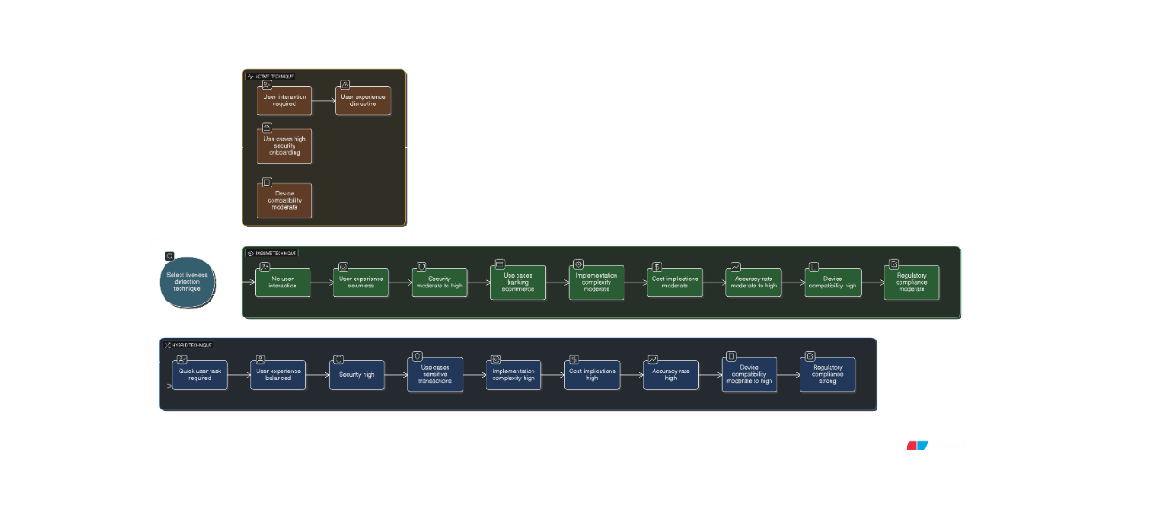

Figure 3.1 Implementation diagram

3.6 Real-World Implementation and The Path Forward
3.6.1 Case Studies in Banking and Healthcare
Finance: Biometrics and behavioral traits provide secure logins, avoiding fraud and continuous risk evaluation. {Healthcare:} ensures accurate, private access to medical records; biometrics at the patient's bedside stop fraud and errors.
3.6.2 Ethical Considerations: Privacy, Data Security, and Regulation
Biometrics present significant risks despite their security benefits because they are unchangeable when they are stolen.

Conclusion
Passwords have given way to unimodal biometrics and now AI-powered Intelligent fusion and advanced liveness detection powered by AI/ML form the This future depends on a dynamic, learning ecosystem balanced with strong ethics and legal principles rather than a single supernatural quality. Rather than a single supernatural attribute, this future depends on a dynamic, learning ecosystem that is balanced with strong ethical and legal principles.

- Designing the Decentralized Multi-Biometric Identity System (DMIDS)

4.1 Introduction: A Paradigm Shift in Digital Identity
The evolution of digital identity will shift from current consolidated, centralized, and federated identity models towards enabling individuals to control, manage and present their credentials without being dependent upon any intermediaries for relative security & privacy.
With respect to meeting many of the most fundamental limitations associated with the older systems, DMID does this by using an architectural model that provides a very high level of visibility regarding credential validity while still preserving user privacy as much as possible.. DMID eliminates centralized data honeypots while providing for accurate verifiability and worldwide interoperability by integrating edge biometrics, advanced cryptography, and privacy-preserving proofs with blockchain-based trust anchoring.

DMID is built upon two foundational W3C standards:
- Decentralized Identifiers (DIDs) identifiers that are globally resolvable and cryptographically verifiable without the need for a central
registry.
When combined, DIDs and VCs offer a privacy-compliant, user-controlled identity ecosystem that complies with GDPR, NIST 800-63-4, and eIDAS 2.0 standards.

4.2 High-Level Architecture Overview
DMID uses a modular, decoupled architecture to optimize resilience and
privacy. The conceptual architecture is shown in Figure 4.1.
Core Components
4.3 Component Roles and Interactions
creation and biometric capture are strictly off-chain. the hash or Merkle root is anchored on-chain after extracted features are combined and hashed. In order to achieve minimal trust assumptions, verification makes use of private off-chain templates and public on-chain data.

4.4 Digital Identity Lifecycle
4.4.1 Enrolment and Issuance

- The user uses their device to scan identity documents and collect biometrics.
- IdP creates a biometric template and uses OCR/AI to extract attributes.
- Every attribute is encoded into a Merkle Tree, and the Merkle root is maintained on-chain.
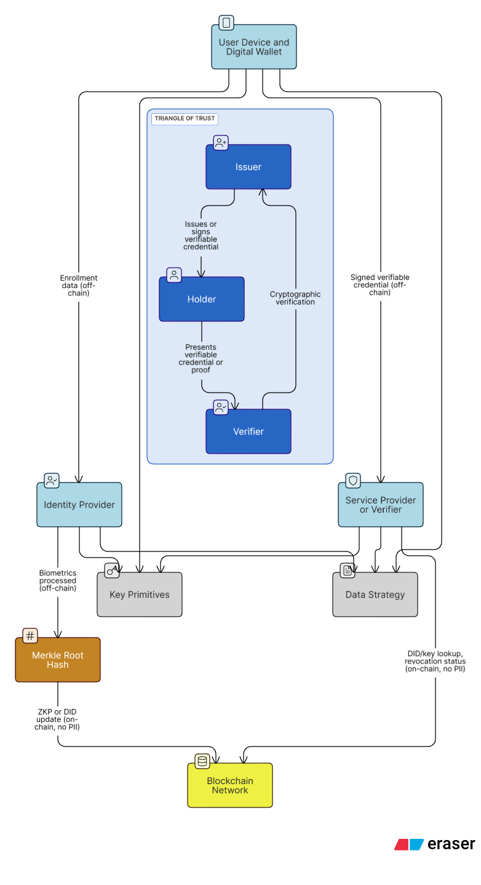

4.4.2 Verification and Authentication
1. A live biometric sample and the VC are presented by the user.
2. The Verifier validates:
  - public key of the issuer through on-chain DID resolution.
  - VC digital signature.
  - Revocation status through the registry.
  - biometric match (using a zero-knowledge proof or off-chain).
4.4.3 Ongoing Management and Revocation
· Update requests, credential revocation, and key rotation are all feasible.
· Complete user sovereignty ensures independent credential lifecycle control.
· Complete user sovereignty guarantees independent credential life-cycle control.

Phase | Actors | Input | Output
Enrolment | Holder, IdP | PII, ID documents, biometrics | VC, off-chain template, Merkle root tree
Verification | Holder Verifier | VC, live biometric | , Authentication decision
Management | Holder, Issuer | Update/revoke request | Updated on-chain status, new VC
Table 4.1: Actors, Inputs, Outputs, and Goals in the Digital Identity Lifecycle

4.5 Data Strategy: On-Chain versus Off-Chain Design
4.5.1 Why Biometrics Must Stay Off-Chain
It is against privacy principles to store biometrics on-chain (GDPR Art. 9, right to erasure).
- Private keys, templates, and raw biometrics are all kept off-chain.
- Merkle roots and hashes are the only cryptographic commitments that go on-chain.
4.5.2 On-Chain: Immutable Proof Anchoring
- DID Documents and verification keys
- Credential or template hashes
- Merkle roots for batched attributes
- Revocation registries
Criterion | On-Chain | Off-Chain
Cost | High | Low
Scalability | Limited | High
Integrity | Permanent | Verified via hash match
Privacy | No PII allowed | Full control & eras ability
Use Cases | DIDs, hashes, revocation | Biometrics, documents, keys
Table 4.2: On-Chain vs. Off-Chain Storage Strategy

4.6 Performance and Scalability
DMID utilizes modern blockchain scalability primitives:
· ZK or Optimistic Rollups for batching verification.
· Sidechains for operations with high throughput, such as enrollments.
· Merkle Trees to create a single hash by compressing hundreds of attributes.
· Sharding to make identity operations more parallel.

4.7 Trust Models in a Decentralized Identity System

4.7.1 Triangle of Trust: Issuer–Holder–Verifier
· Issuer makes credentials and signs them.
· Holder presents proofs and manages the wallet.
· Verifier Verifies proofs without getting in touch with the issuer.
proof of age without disclosing the date of birth.

4.7.2 DIDs and VCs
· DIDs map to public keys stored in blockchain-anchored DID Documents.
· VCs are digitally signed JSON-LD assertions bound to the holder.
· They support selective disclosure and privacy-preserving presentations.
4.7.3 Zero-Knowledge Proofs (ZKPs)
Conclusion
DMID presents an exceptionally structured process for implementing safe biometric identity. Through the implementation of advanced Cryptography techniques such as Decentralized Identifiers (DIDs), Verifiable Credentials (VCs) and Zero-Knowledge Proofs (ZKPs), together with thorough mechanisms that protect against unauthorized access to sensitive data, DMID assures Individuals across multiple Regions the ability to control their data in a Privacy preserving manner, while achieving not only Privacy protecting and user control on a very large scale but also increasing the Scalability of the overall biometric.

- Cryptographic Engineering
for Ultimate Privacy and Security

5.1 The Foundation of Trustless Verification: Merkle Trees
Each Merkle tree is filled with hashes creating branches from the root. All of these hashes are combined through a ‘parenting’ or recursive method to produce one hash at the top of the Merkle tree. This approach allows for the confirmation of all dataset blocks in logarithmic time to achieve a very fast response.
5.1.1 Merkle Proofs: Enabling Lightweight and Private Verification
A Merkle proof (also called a Merkle path) shows that a specific datum is a part of a set without disclosing the complete dataset. To verify the commitment, a Verifier recalculates the sequence. This is essential for selective disclosure of personal characteristics, such as demonstrating age eligibility without providing the exact year of birth.

5.1.2 Real-World Applications and Engineering Context
Merkle trees are utilized in peer-to-peer file systems for integrity checks, anti-entropy protocols in distributed databases, and blockchains (in which aggregate thousands of transactions in a block).

5.1.3 Engineering Challenges and Advanced Architectures

Since it is costly to update or grow traditional Merkle trees for dynamic
data, structures like Ethereum’s Merkle Patricia Tries combine hash and trie logic to perform successful dynamic operations.
5.2 Proving Without Revealing: The Paradigm of Zero-Knowledge Proofs (ZKPs)

With a Zero-Knowledge Proof (ZKP), a Prover may convince a Verifier
that a statement is true without disclosing any additional details. ZKPs
have:
· Completeness: If the statement is true, an honest Verifier might persuade another honest Verifier.
· Soundness: If a statement is untrue, and there is very little chance that a dishonest Prover will persuade the Verifier.

Part II

Architecting, Developing, and
Deploying the Next-Gen Identity
System

- Development Of Designing the Decentralized Multi-Biometric Identity System (DMID)

6.1 Introduction
A fast and secure verification of large amounts of data to establish their integrity is made possible using a hierarchical data structure named Merkle Tree, also known as a Hash Tree. Whereas the hashes of their descendents are stored in non-leaf nodes. A single "Merkle root," symbolical of the integrity of a Merkle Tree, is generated using this recursion technique. Verification of any block of data is possible fast, efficiently, and in a logarithmic time using this technique. Merkle proofs are one of the building blocks of scalable public blockchain technology; they allow light clients to validate transactions without downloading any datasets
DMID develops a strong, scalable identity ecosystem by integrating fingerprint scanning, camera modules for facial recognition, and decentralized ledger storage. We can achieve memory safety and concurrency without the drawbacks associated with traditional C++ or Python in embedded contexts by using Rust for firmware development on ESP32- based devices.

6.2 System Architecture
The DMID architecture is modular and consists of a blockchain layer for decentralized identity management, a central orchestrator for verification, and edge devices for biometric acquisition. Significant hardware
parts consist of:
- ESP32-S3-N16R8: The central processing unit, or CPU, is a high-performance microcontroller with AI acceleration. Its large PSRAM (8MB) is essential for hosting the fusion network and high-dimensional feature vectors.
- ESP32-CAM with ESP32-CAM-MB: A development board for pro- to typing has been added to an integrated camera module for facial
biometric capture. This regulates the visual modality and initial liveness checks.
- Fingerprint Sensor: The tactile modality is provided by an optical or capacitive sensor (such as AS608) for fingerprint enrollment and verification.

To create a network and ensure fault-tolerant data flow, these parts
connect via Bluetooth Low Energy (BLE) or Wi-Fi.

6.3 Diagram: DMID IoT Hardware Integration

The integration of the identified IoT components in the DMID edge node is depicted in the following diagram. It shows how data flows securely to the decentralized network from biometric sensors to the ESP32-S3 processor.

The ESP32-S3-N16R8, which gathers biometric data from the ESP32-
CAM (for facial features) and the fingerprint sensor, is shown in this
diagram as the central hub. After being hashed, the combined data is
sent to the decentralized ledger for unchangeable storage.

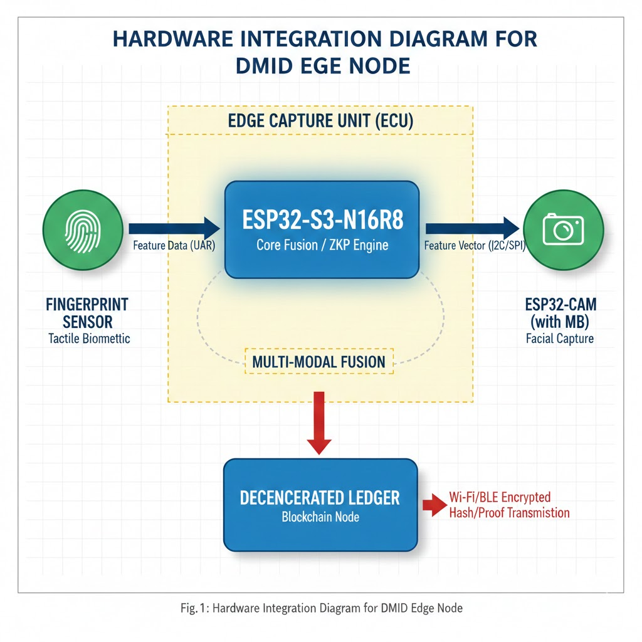Figure 6.1: Hardware Integration Diagram for DMID Edge Node

6.4 Implementation: Rust Firmware Sample
We use Rust’s esp-rs framework for firmware development, which guarantees memory safety and concurrency appropriate for real-time biometrics. A simplified Rust code sample showing the collection and hashing of biometric data on the ESP32-S3 can be found below. After configuring the fingerprint sensor via UART and obtaining a frame from the
Note:The esp-idf-hal and embedded-hal crates are needed for complete implementation; this is merely a conceptual snippet.
Listing 6.1: Simplified Rust Firmware for Biometric Acquisition and Hashing
use sha2::{Sha256, Digest};
use anyhow::Result;

fn main() -> Result<()> {
// ---------------------------------------------------------------------
// 1. System Setup
// ---------------------------------------------------------------------
esp_idf_sys::link_patches();

let peripherals = Peripherals::take()
.expect("Failed to take peripherals");

let _sys_loop = EspSystemEventLoop::take()?;
let _pin_config = Default::default();

// ---------------------------------------------------------------------
// 2. Fingerprint Sensor Initialization (UART)
// NOTE: Replace `peripherals.modem` with the actual UART peripheral
// ---------------------------------------------------------------------
let fp_uart = Uart::new(
peripherals.modem,
peripherals.pins.gpio17, // TX
peripherals.pins.gpio18, // RX
&Config::default(),
)?;

// ---------------------------------------------------------------------
// 3. Camera I2C Initialization
// ---------------------------------------------------------------------
let sda = peripherals.pins.gpio8;
let scl = peripherals.pins.gpio9;

let i2c = I2cDriver::new(
peripherals.i2c0,
sda,
scl,
&esp_idf_svc::hal::i2c::I2cConfig::new().baudrate(100.kHz().into()),
)?;

// ---------------------------------------------------------------------
// ---------------------------------------------------------------------

// Fingerprint buffer (example size)
let mut fp_buffer = [0u8; 512];
// Real implementation would read from UART protocol
// fp_uart.read_exact(&mut fp_buffer)?;

// Camera frame buffer (example size)
let mut cam_frame = [0u8; 1024];
// Real implementation would configure sensor registers
// i2c.write_read(0x21, &[], &mut cam_frame)?;

// ---------------------------------------------------------------------
// 5. Feature-Level Fusion and Hashing
// ---------------------------------------------------------------------
let mut fused_data = [0u8; 1536];

fused_data[..512].copy_from_slice(&fp_buffer);
fused_data[512..].copy_from_slice(&cam_frame);

let mut hasher = Sha256::new();
hasher.update(&fused_data);
let hash = hasher.finalize();

// ---------------------------------------------------------------------
// 6. Output / Transmission (e.g., Wi-Fi → Ledger)
// ---------------------------------------------------------------------
println!("Biometric Hash: {:?}", hash);
Ok(())
}

By using the ESP-IDF HAL for hardware abstraction, this Rust sample ensures. By preparing data for blockchain inscription, the hashing stage maintains decentralization.

6.5 Deployment Considerations
During deployment, a Substrate-based blockchain is integrated with DMID's Upon turning on, edge nodes automatically enroll in the network using over-the-air (OTA) updates for scalability.
- Cryptographic Engineering for Ultimate Privacy and Security

7.1 Cryptography as the DMID Trust's Foundation
The primary objectives of the DMID are absolute privacy and proper authentication. The raw data must always be present in the Edge Capture Unit (ECU). The primitives that are needed for the proof of identity against the decentralized ledger without revealing the data are delivered by the field of **cryptographic engineering**.

7.2 Biometric Template Transformation and Hashing
The raw biometric inputs (facial vector Ff ace and fingerprint minutiae Ff p) are merged into a fused template Ff used inside the ESP32-S3-N16R8's secure enclave. Next, A cryptographic hash with a fixed length

7.2.1 Non-Reversible Hashing (SHA-256)
It creates a solid identity for that thing; as long as the hashing can be done the same way every time (through the use of Hardware Security Modules), that hashed outcome is a solid confirmation of identity. The hashing technique ensures that the original biometric template Ff cannot be restored in case the secured HDMID stored in the decentralized ledger is revealed.
H_{DMID} = SHA-256(F_{f used})

7.3 Zero-Knowledge Proofs (ZKPs) for Authentication
The method used by the ECU to verify the user identity (via ZKPs) during a future logon, allows for the ECU to demonstrate it knows the correct biometric hash (HDMID) to the verifying party (the DApp or blockchain) without transmitting the HDMID to the verifying party.
Role of ZKPs
The Zero-Knowledge Proof protocol makes an authentication challenge a non-interactive proof of knowledge by rephrasing the following:
- Prover (ECU/ESP32-S3): The user performs a new biometric scan for H-New with which to compute a ZKP, π for the ECU to demonstrate H-New is valid in relation to HDMID.
- Verifier (Blockchain Smart Contract): The verifier verifies proof π using the known biometric scan.

7.4 Hardware Security and Acceleration on ESP32- S3

7.4.1 Dedicated Cryptographic Accelerators
Common cryptographic operations are accelerated by specialized hardware modules in the ESP32-S3 architecture.
- SHA Accelerator: reduces the latency of the enrollment and authentication processes by accelerating the SHA-256 hashing procedure used to generate H_{DMID}.
- ECC Accelerator: Digital signatures are based on Elliptic Curve Cryptography (ECC), which is necessary for many ZKP implementations (such as those in the zk-SNARKs family).
7.4.2 Secure Boot and Flash Encryption
The ECU firmware makes use of the ESP32-S3’s built-in security features to guard toward tampering and illegal firmware injection:
  - Secure Boot: stops malicious actors from replacing the biometric processing code by ensuring that the ESP32-S3 only runs signed firmware images.
  - Flash Encryption: To prevent physical read-out attacks, the AI/ML model weights and significant cryptographic keys including the private key required to sign the ZKP are kept in encrypted flash memory.
7.5 Code Integrity with Rust and Compile-Time Checks
Rust guarantees software integrity in alongside hardware. Buffer over-flows, data races, and unauthorized memory access vulnerabilities that are frequent attack vectors in embedded C/C++ implementations and could jeopardize the ECU’s cryptographic integrity are all prevented by the language’s strong safety guarantees.

- Intelligent Architectures of Fusion: A Technical Deep Dive

8.1 The Imperative for Fusion at the Edge
The DMID system uses multi-biometrics to improve the authentication process’s security (increased resistance to spoofing) and accuracy (lower False Acceptance Rate, or FAR). In order to maintain the privacy mandate that raw biometric data never leaves the device, facial and fingerprint data must be integrated at the Edge Capture Unit (ECU).

8.2 Feature-Level Fusion vs. Score-Level Fusion
Score-level are risk can be access by the unauthorize entity , other side feature -level can be hack by any one also it make average of the two or more then two factors

8.2.1 Score-Level Fusion (Rejected)
Each modality is matched independently to generate a confidence score in score-level fusion, which is then combined (e.g., averaged or weighted). The rich, non-linear relationships between the features of the two modalities are lost in this computationally light approach, which results in the loss of important information.

8.2.2 Feature-Level Fusion (Adopted Strategy)
In the feature-level fusion implementation of DMID, the low-dimensional feature vectors extracted from both Ffp and Fface are integrated into a single vector, Ffused *before* the matching or final hashing. This maximizes the uniqueness factor, which is critical for enhancement of security.
F_{f used} = F _{f used} ⊕ F_{fp} (where ⊕ denotes vector concatenation)
This concatenated feature vector is then fed into a specialized neural network in order to reduce dimensionality and improve the template.

8.3 The Role of the ESP32-S3’s PSRAM in Fusion
Particularly when using neural networks, the complexity of feature-level fusion requires significant memory resources that are unavailable on standard microcontrollers.
PSRAM and Fusion Engine
The main memory pool for the fusion engine is the **8MB of external PSRAM (R8)** of the ESP32-S3-N16R8. This ability is crucial for a number of reasons:

- Hosting Weights: The dual-core LX7 processor can quickly access the weights and biases of the optimized Fusion Neural Network (FNN) by loading them into PSRAM.

- Vector Buffering: PSRAM is used to temporarily store and
concatenate the high-dimensional feature vectors (such as F_{face} up to 512 floats and Ff p up to 256 floats) that were taken from the camera module and fingerprint sensor.

- Intermediate Output: In order to avoid memory starvation and performance bottlenecks on the smaller internal SRAM, intermediate activation maps during FNN processing are stored in PSRAM.

8.4 Neural Network Design for Embedded Fusion
shallow, dense network architecture designed for binary classification or verification is the Fusion Neural Network (FNN). It is trained to minimize intra-class variance (reliably identifying the same user) and maximize inter-class variance (differentiating users).
8.4.1 Model Optimization
The FNN needs to go through rigorous optimization before deployment because of the limitations of the ESP32-S3 (even with PSRAM):
· Weight Quantization: By utilizing the ESP32-S3’s effective integer
operations, converting 32-bit floating-point weights to 8-bit or 16- bit integers significantly reduces model size and accelerates matrix multiplication using fixed-point arithmetic.
· Pruning: The system achieves its real-time processing objective by
removing superfluous network connections, which also reduces the memory footprint and speeds up inference time.

- The Neural Revolution:
AI/ML as the Engine of Intelligent Authentication

9.1 The Centrality of AI/ML in DMID
The DMID system’s intelligence layer is made up of AI/ML techniques that mainly work with the Edge Capture Unit (ECU). This chapter de- scribes how machine learning models are used to first convert raw bio- metric inputs images and sensor data into secure, low-dimensional feature vectors appropriate for fusion and cryptographic hashing, whereas Chapter 3 concentrated on how features are combined (fusion).

9.2 Deep Learning for Facial Feature Extraction
The raw image data obtained by the ESP32-CAM is the first step in the process. Convolutional Neural Networks (CNNs) designed for edge devices with limited resources are the foundation of facial authentication.

9.2.1 CNN Architecture and Constraints
The ESP32-S3’s PSRAM stores the model weights of a highly effective CNN (such as MobileNetV2 or TinyML variations) used in the facial feature extractor.

- Input Processing: The normalized face image, which is frequently resized and pre-processed by the ESP32-CAM’s specialized hard- ware, is accepted by the CNN.
- Feature Vector Generation (F_{f ace}): The model reduces the image size to a compact, numerical vector by performing a series of convolutions and pooling operations. In order to preserve privacy, this vector is made to be non-reversible while retaining discriminatory information (specific facial markers). Ff ace is typically a vector with 512 floating-point values.
- Deployment Approach: To enable effective execution on the dual-core LX7 processor of the ESP32-S3, the CNN is converted to a highly quantized format (such as TensorFlow Lite Micro).

9.3 Intelligent Extraction from Fingerprint Data
Algorithms are needed for the tactile biometric subsystem to handle incomplete or noisy fingerprint sensor input.

9.3.1 Minutiae and Ridge Feature Extraction
DMID employs a complementary neural approach on the ESP32-S3 to generate a reliable and consistent feature vector (Ff p), whereas con-ventional fingerprint systems rely on mathematical algorithms to find minutiae points (ridge endings and bifurcations).
- Image Enhancement: The raw fingerprint sensor image is first cleaned by a tiny neural network filter (ridge thickening, noise removal).
- Template Generation (F_{fp}): The improved fingerprint image patch is processed by a specialized shallow CNN or a trained autoencoder to extract an abstract feature vector, reducing reliance on precise minutiae coordinates and boosting resilience to slight positional variations. Usually, this results in a vector with 256 fixed-point values.

9.4 The Training Mandate: Maximizing InterClass Variance
The quality of the feature vectors generated by these networks is crucial to the success of AI/ML in DMID.

Maximizing Template Quality
Triplet loss or contrastive loss functions are used to train the neural networks for fingerprint and face extraction. The model is forced by this training objective to minimize the distance between multiple samples from the same user (” Intra-Class Variance”) and maximize the distance between feature vectors belonging to different users (” Inter-Class Variance”).
Loss = max (0, ||F_{a} − F_{p}||2 − ||F_{a} − F_{n}||2 + α)
where F_{a} is anchor, F_{p} is positive (same user), F_{n} is negative (different user), and α is the margin.
The final fused template (F_{fused}), which is derived from F_{f} ace and F_{fp}, is guaranteed to be extremely unique and resistant to False Acceptance thanks to this training procedure.

- The Unblinking Eye: The Crucial Role of Liveness Detection

10.1 The Threat of Presentation Attacks
This is where liveness detection, or anti-spoofing, becomes an important part of a biometric system; it establishes whether the underlying biometric information is being captured from a real, live individual at the time of capture as opposed to a fake reproduction.

10.2 Layered Liveness Detection in DMID
DMID has developed a multi-layered, defence-in-depth approach to securing digital assets that combines both active and passive liveness checks that make use of the unique functionality of the ESP32-CAM and the fingerprint sensor.

10.2.1 Passive Facial Liveness (On-Camera)
By eliminating the requirement for user interaction and using a lightweight machine-learning model that runs using the ESP32-CAM image pipeline unless there is not enough room for power within the device, passive detection speeds up authentication. This model works with the image data generated by the ESP32-CAM.

To understand how this works in practice: First, the machine-learning model analyses the image for abnormalities. For example: the appearance of the image could be flat like an ordinary photograph or might have signs of reflection, which is commonly associated with printed However, these characteristics can reveal to the model that the image has been manipulated; this is why the analysis of these characteristics is so important.

Secondly, depth checking of the face will indicate that there is some movement occurring. For instance, when the face is shown in a video, a small amount of twitches or shifts can be seen from frame to frame. An image cannot hide this kind of movement, so it is essential for the model to assess micro-movements to determine if the image represents what it says it does.

After evaluating the image, the model uses a compact neural network — essentially a sophisticated filter — to review several patches of the image, which allows it to assign a probability (Plive) to the likelihood that a viewer is seeing a legitimate representation of the face.

10.2.2 Active Facial Liveness (Challenge-Response)
Active liveness adds a challenge-response mechanism controlled by the main ESP32-S3 processing unit for increased security requirements.
- Randomized Challenge: The user receives a command from the ECU (such as ”Blink once,” ”Turn head slightly left”).
- Sequence Verification: Within a constrained time frame, a sequence recognition model (such as a small Recurrent Neural Network or a basic CNN processing frame-to-frame differences) confirms that the observed video stream corresponds to the directed action. Rejection occurs when the dynamic action is not executed or when the movement is out of order.

10.3 Tactile Liveness Detection for Fingerprints
For the fingerprint modality to prevent attacks with silicone molds, gelatin, or latent prints, liveness detection is essential.

10.3.1 Sensor-Based Biometric Signals
A fingerprint sensor that can record signals other than the ridge pattern is required by the DMID design.
Capacitive/Temperature Readings: Contemporary capacitive sensors are capable of detecting heat and measuring variations in capacitance across the skin’s surface. Temperature and capacitive signatures will be recorded incorrectly or uniformly by a non-living replica, like a gelatin mold indicating a spoof.
Pulse or Blood Flow: Micro-pulsations that indicate blood flow can be detected by sophisticated optical or capacitive sensors. Before permitting feature extraction, the ESP32-S3 firmware verifies the presence of a living finger by processing this raw sensor signal using straightforward signal processing algorithms.

10.4 Liveness Aggregation and Final Authenti-
Catio n Gate The liveness checks are integrated into the overall fusion pipeline by the DMID system

Liveness and Fusion Gate
Successful liveness validation is a prerequisite for the final fusion process (Chapter 3). The gating mechanism is the liveness status.:
Accept = $\left\{TRUE if\left(P_{l}≥τ_{f}\right)∧\left(S_{t}=TRUE\right)∧\left(ZKPValid\right)\right\}$
where P_{live} is facial confidence, Stactile is tactile liveness status, and τ_{face} is the required threshold. The robustness of the authentication process is greatly increased by this layered defense, which guarantees that an attacker must simultaneously defeat multiple, independent security checks operating across various hardware modules (camera ML, S3 signal processing, S3 core cryptography)

- Real-World Implementation and The Path Forward

11.1 Hardware Assembly and PCB Integration
The Edge Capture Unit (ECU) must be industrialized in order to go from prototype to deployment.
11.1.1 Finalized ECU Design
The development boards are combined into a single small printed circuit board (PCB) centered on the ESP32-S3-N16R8 by the production ECU.

Physical Interconnects: Every connection matters here UART handles fingerprints, DVP or I2S takes care of camera data, and I2C or SPI deals with control signals. PMUs help maintain data integrity, while minimizing interference from EMFs.
PMU (Power Management Unit): The ESP32-S3 keeps its dual core CPUs and PSRAM powered with a constant supply of electricity by using a dedicated PMU (Power Management Unit). This allows the PMU to provide additional power to increase performance if the ESP32-S3 requires extra power when Wi-Fi and/or AI operations are performed.
Tamper-resistant/Enclosure Protection: The S3 has a variety of sensors, including internal sensors that detect vibration, light, etc., wired to its GPIO (Let Franco know if you need a further explanation) pins, and those sensors will notify you if there is any indication that someone has tampered with your device. Any cryptographic keys or stored templates on the device must be immediately securely deleted by the ECU in the event that unauthorized access is discovered. 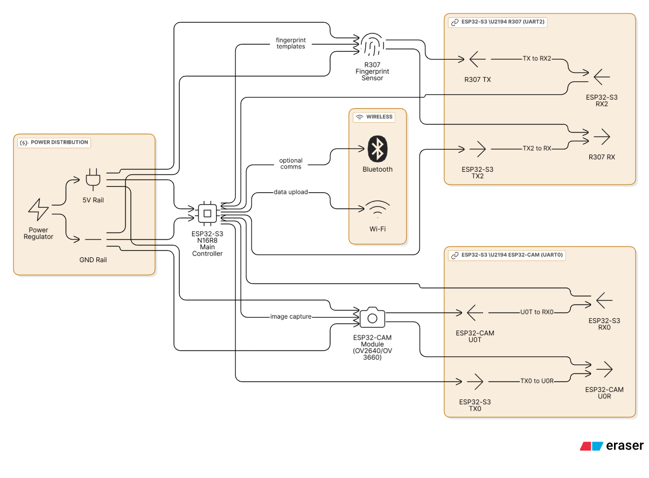

Figure 11.1 Hardware work Flow + Connection

11.2 Firmware Development and Real-Time OS
Although Rust’s safety features are used in the conceptual code, a stable
operating environment is needed for the real-world deployment.

11.2.1 Real-Time Operating System (RTOS)
To handle the concurrent high-priority tasks, the DMID application uses the ESP-IDF RTOS (FreeRTOS):

- Core 0 (Control and Crypto): devoted to overall system control (Wi- Fi, Bluetooth, power management) and cryptographic operations (ZKP generation).
- Core 1 (Biometric Processing): committed to minimizing latency in the authentication pipeline by executing the ML models for feature extraction, fusion, and liveness checks.

1.2.2 Continuous Integration and OTA Updates
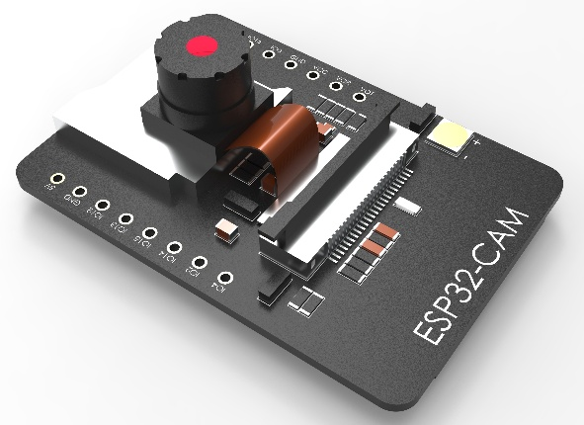
A safe Over-the-Air (OTA) update system is put in place. The issuer’s ECC private key is used to sign firmware updates, and the ECU uses the public key kept in the secure boot hardware before flashing the new binary.
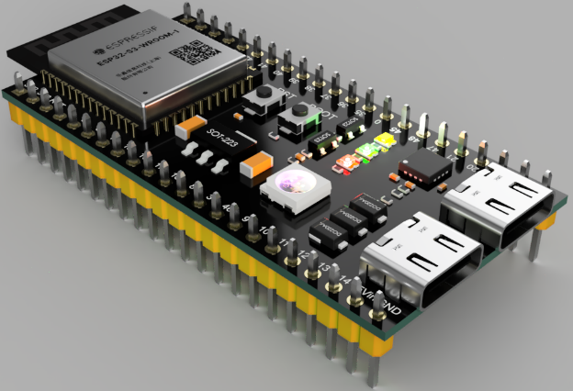

Figure 11.2 ESP-32-S3 devlopment bord Figure 11.3 ESP-32-CAM
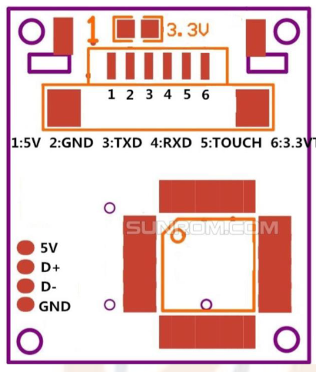
Figure 11.3 R307 Fingerprint Module

11.3 Roadmap and Future Enhancements

The DMID architecture in use today is a fundamental implementation. Scaling the system and improving security features will be the main goals of future development.
11.3.1 Scaling the Decentralized Network
The integration of blockchain Layer-2 scaling methods (ZK-rollups and Optimistic Roll-ups) enables the management of any volume of transaction activity globally while taking advantage of the security afforded by the primary (Layer 1) Decentralized Ledger to achieve a Level 1-power Level of Scaling, or rather extreme throughputs.
- Researchers are currently exploring Shamir's Secret Sharing method (SSSS), which enables the distribution of the Master Identity Key to different De-Centralised Storage Vectors (i.e., Different Nodes and/or Shards) to increase the level of resilience and the capacity for User Recovery.
11.3.2 Advanced Biometric and AI Capabilities
Use an External IR Camera to Scan Your Iris: Adding an external infrared camera for iris scanning means a lot of extra biometric detail about you! Adding the external IR camera to an ECU also allows for building templates that are even more accurate and distinct from each other.

Improve Accuracy at the Edge Using Federated Learning: When you apply federated learning, the AI models are being improved right on the ECU. They are learning from local sensor data but without ever sharing any of the actual data. All that gets done is that the AI model updates the weights and sends them back to the ECU. You then preserve your privacy while increasing accuracy with each iteration of the learning process.

12. User Experience and Accessibility in Digital Identity
12.1 The UX Imperative: Balancing Security and Usability
When a security system that is unusable is imposed on users, such a system will have limited utility for customers. Addressing user frustration through UX Design should therefore involve creating a DMID platform that is simple to use, fast, and gives users appropriate and clear feedback about what is occurring within and through the course of use, especially for users who will capture biometric data.

12.2 Optimization for Seamless Interaction
12.2.1 Low Latency Feedback Loop
The integration of local AI/ML processing on the ESP32-S3 directly addresses latency requirements.

Auditory and Visual Cues: The Edge Capture Unit (ECU) provides immediate feedback. In close proximity to the sensor and camera are green and red indicator LEDs. A small speaker or buzzer indicates that the system is ready, that a capture was successful, and whether or not the authentication was successful. All of this information will be sent via the dedicated General Purpose Input/Output (GPIO) pin.

12.2.2 Guided Enrolment Process
The first step in getting enrolled is typically more challenging than any other step, so if you keep everything as simple as possible, it helps make things easier going forward. You will see clearly defined instructions for each step of enrollment on the ECU firmware. The face capture comes first, then you will be doing your fingerprints; and yes, you may have to repeat these steps a few times, but that is part of how you create a strong, high-quality template that will help reduce the potential for false rejections later on.

12.3 Accessibility Considerations
12.3.1 Alternative Input and Feedback Modalities
Haptic Feedback: It creates vibration feedback that users can feel (buzz) whenever a response is received from their system pass the liveness check or finish an operation.
Multilingual Assistance: The Intent of Multilingual Option is to provide audio and/or text information in any language the user requires based on the amount of flash memory required will depend on how many languages are required. The system also enables the use of text-based liveness challenges; therefore, text-based liveness challenges may be presented to the user in their native language.
Adaptive Liveness Parameters: Liveness checks can be adjusted based on the needs of individual users, including those who are limited in their ability to move and/or express themselves through facial features. If a user is struggling physically, the system can automatically adjust the method of motion check to a passive method so that no user will be excluded from participating.

Adaptive Liveness Thresholds: You can tweak the liveness checks. If someone struggles with movement or facial expressions, the system can switch to easier motion checks or passive methods, so people aren’t left out.

12.4 Self-Sovereign Identity (SSI) and User Control
Identity Control and Recovery
The user's sovereign agent is the ECU.
- Biometric data minimization and data minimization transparency – Users must understand how their biometric data are only transferred as a non-reversible cryptographic hash (an HDMID) off the device to protect the privacy of their biometric data.
- Revocation and Recovery: For important management functions, such as the following, the ECU must provide obvious interface points (such as physical buttons or a local web inter face hosted by the ESP32):
- starting the local biometric template’s secure destruction right away.
- initiating the recovery process, probably using Shamir’s Secret Sharing, the decentralized key management solu tion described in the roadmap.

13. Interoperability and Standards: Bridging Identity Silos

13.1 The Need for Identity Interoperability
For the DMID system to catch on, it has to play nicely with all sorts of other systems, apps, and identity networks.

13.2 W3C Decentralized Identifiers (DIDs)
The framework required to create globally unique, self-owned identifiers based on the blockchain layer is provided by decentralized identifiers (DIDs). This is the fundamental component of the interoperability of DMID.
13.2.1 DMID Identifier Structure
The immutable cryptographic hash (HDMID) produced from the fused biometric template (??) is directly linked to the primary identifier for a user’s DMID
DID Method: DMID uses a custom or compliant DID method (such as did:dmid:) based on the user’s base identity hash stored in a decentralized ledger.
DID Document: Cryptographic information used for verification, including the public key linked to the user’s ZKP generation process, is contained in the DID Document, which is kept publicly on the ledger (or a related distributed file system). Crucially, the biometric hash itself is contained in this document never.
13.3 Verifiable Credentials (VCs)
Without disclosing the underlying biometric data, Verifiable Credentials (VCs) allow the safe, private exchange of identity-related characteristics.
13.3.1 Issuance and Presentation
Credential Issuance: VCs are issued to the user’s DID (managed by the ECU) by trusted third parties, such as governments and banks. An attribute (such as age or verified citizenship) is digitally attested to by this credential.
Credential Storage: The ECU stores VCs safely in its encrypted flash memory. That means the user stays in control shared attributes never end up on the public ledger.

Presentation of Credentials: When a verifier asks for proof, like checking if someone’s over 18, the ECU steps in. It uses its private key to make a Verifiable Presentation (VP). This VP packs the needed VC and proof usually a zero-knowledge proof showing the VC matches the biometric identity being presented.

13.4 Standards for Embedded Communication
The ECU uses low-level communication protocols that work smoothly with the decentralized network.

13.4.1 IoT Protocol Integration
The ESP32-S3 relies on standard IoT protocols to make sure the network stays reliable and compatible:
- MQTT (Message Queuing Telemetry Transport): This handles lightweight, asynchronous communication with the decentralized app layer. It’s great for sending small VC requests and proofs over cellular or spotty Wi-Fi.

-TLS/SSL: That way, ZKPs and VCs stay private and protected from tampering.

14. The On-Chain vs. Off-Chain
Paradigm in Data Strategy

14.1 Principle of Data Segregation: Privacy by Design
Privacy by default sits at the heart of the DMID system’s data strategy. The system uses a strict two-layer approach: only public, irreversible proofs go on-chain, while all sensitive, detailed data stays off-chain, safely under the user’s control in the ECU.

14.2 Off-Chain Data: The Secure Edge Enclave
Privacy by default sits at the heart of the DMID system’s data strategy. The system uses a strict two-layer approach: only public, irreversible proofs go on-chain, while all sensitive, detailed data stays off-chain, safely under the user’s control in the ECU.
14.2.1 Sensitive Biometric Data
At the heart of DMID's data strategy is its use of privacy by default. The DMID system has adopted a strict two-layer architecture. Only public and irreversible proof will be stored on the chain, while all private and sensitive information remains stored locally on the user's ECU.
Raw Sensor Data - This type of data is an unprocessed electrical signal collected from a fingerprint scanner and image capture through an ESP32-CAM.
Extracted Feature Vectors - An Extracted Feature Vector provides an efficient way to compress biometric data into smaller collections of numbers without losing any valuable information about the original biometrics (fingerprint and face). An Extracted Feature Vector acts as a way to "shorten" the original biometrics into a smaller representation before being combined into a fused biometric template.
Fused Biometric Template - A Fused Biometric Template consists of the combined Extracted Feature Vectors from a fingerprint and face into one unique identity hash.
The Fused Biometric Template may not be transmitted over the Internet.

14.3 On-Chain Data: Immutable Proofs and References
On-chain layers are immutable and are designed to provide an indisputable, verifiable record of information relevant for interoperability, revocation, verification but cannot be linked directly to someone's biometric information.
14.3.1 The Identity Root and Public Keys
The ledger contains only the most essential information that can be checked publicly by other individuals. · DMID Identity Hash (HDMID): The irreversible (SHA-256) hash created from a fused biometric template and is considered the foundational element of trust
14.4 Data Integrity and Chain of Custody
The 'chain-of-custody' is "locked-down" via a segregation model; the decentralized ledger provides proof that a particular biometric asset exists and is untampered, as well as a permanent public record of that information. Therefore, only through ECUs will users hold access to the asset; no one else has access.
The Non-Reversibility Guarantee
The DMID system's fundamental security principle is built on the unrecoverable nature of cryptographic hashes to prevent you from recovering your original biometric identity if someone breaks into the blockchain.

You'll have ultimate privacy as long as you're alive, so there is no need to worry about losing your biometric identity.

You're getting the advantages of both strong privacy and cost savings with this system. Because it requires only a very small amount of information (unique cryptographic hash proofs) to be stored on the blockchain, you won't have to spend a lot on the storage space required to support that digital footprint in the future, and it requires less bandwidth.
15. Addressing Scalability
and Performance Challenges

15.1 Scalability Imperatives for Decentralized IoT
The antithesis of a decentralized identity system for global use on a constraint-based Internet of Things (IoT) hardware is its larger scalability/performance issues, which are resolved through the Degree-of-Maturity Indices (DMID) architecture by efficiently distributing the computation workload and incorporating specialized hardware accelerators.
15.2 Performance Optimization on Edge Devices
The principal technique for addressing the increased transaction volume generated by high transaction throughput while preserving real-time performance is the transfer of computational work performed by slow and expensive blockchain-based layer to highly capable edge devices.
Computational Offloading and Resource Management
The Edge Capture Unit (ECU) executes the complete biometric process directly at the location of data capturing, from capturing the biometric information to producing a proof of identity. Following completion of the biometric certification process, the ECU consolidates all individual entries into a single validated transaction and transmits them to the principal decentralized ledgers (or databases) of the identity network.
- Pushing intensive feature extraction and fusion to the specialized edge device (ESP32-S3) is one way to decentralize computation.
- Only publishing minimal, irreversible data (public keys and hashes) is one way to minimize on-chain data.
- Using established scaling frameworks to mitigate the global transaction validation bottleneck is one way to leverage Layer-2.
15.4 Failure Resilience and High Availability
To guarantee that the system continues to function even in the event of a partial failure, scalability and resilience must be combined.
15.4.1 Redundancy in Identity Root
An intrinsic level of redundancy and fault tolerance throughout the whole decentralized network is provided by the identity root (HDMID) kept on the blockchain. The distributed ledger’s core identity proof mechanism is still accessible to everyone even if a single verifying node fails..
15.4.2 ECU Autonomy and Offline Capability
The fundamental authentication procedure is intended to function with a high level of independence. Before creating the ZKP, the ECU can verify the user’s current biometric input against its locally stored templates after enrollment.
16. Trust Models in a Decentralized Environment
16.1 The Paradigm Shift from Centralized Authority
Conventional systems of identity rely on an overall authority to establish trust, whereas Digital identity is a system that decentralizes identity.
Pillar 1: Hardware Root of Trust -- Integrity of ECU
Trust begins with hardware. You can expect that your system will be trustworthy; you can only expect it if the ECU is a trustworthy component. It must protect biometric information and the private key; there are no
- Tamper Resistance: The ECU is equipped with a protective case and a built-in tamper detection mechanism.

16.1.1 Pillar 2: Cryptographic Root of Trust (Immutability)
Biometric Hashing (HDMID): The non-reversible SHA-256 hash is the unchangeable digital fingerprint of the fused biometric template. Trust is placed in the mathematical properties of the hash function.
· Zero-Knowledge Proofs (ZKP): The ZKP (??) establishes trust in authentication by mathematically demonstrating the user’s legitimacy without requiring the verifier to have faith in the ECU’s local data storage. The security of the underlying ECC algorithm is the only factor needed to verify the proof. (??).
16.1.2 Pillar 3: Network Root of Trust (Decentralized Ledger)
The identity’s availability and state are anchored by the decentralized ledger.
· Immutability: Long-term identity stability is ensured by the blockchain’s guarantee that the original HDMID and related public keys cannot be changed in the past.
· Availability/Redundancy: Because the ledger is distributed, the identity’s root metadata is extremely accessible and impervious to single points of failure.(15.4.1).

16.2 Trust Delegation via Verifiable Credentials (VCs)
The DMID model delegates the trust associated with a trusted Issuer (such as a bank or government agency) to the user through Verifiable Credentials rather than centrally verifying attributes.(13.3).
Trust in the Credential Ecosystem
A three-way trust relationship is necessary when a Verifier uses a VC to validate an attribute:
- The Verifier has faith in the authority that signed the VC.
- The Verifier has faith in the mathematical signature that demonstrates the integrity of the VC.
- The Verifier has faith in the ZKP, which demonstrates that the VC is currently owned and presented by the legitimate DMID holder (whose identity is anchored by H_{DMID}).
References
[1] S. G. Kong, J. K. Wang, C. S. Kim, and H. Y. Lee, “Edge Computing for Multi-Modal Biometric Recognition using ESP32-S3 and TinyML,” International Conference on IoT and Embedded Systems, 2024.

[2] A. Ross and A. K. Jain, “Information Fusion in Biometrics,” Pattern
Recognition Letters, Vol. 24, Issue 13, 2003, pp. 2115–2125.

[3] S. Goldwasser, S. Micali, and C. Rackoff, “The Knowledge Com-
plexity of Interactive Proof-Systems,” SIAM Journal on Computing,
Vol. 18, No. 1, 1989, pp. 186–208.

[4] Zero-Knowledge Proof-Based Identity Verification in Dis-
tributed Financial Networks. Anonymous. ResearchGate
Publication 396752309, October 2025.

[5] Cross-border candidate credential verification using
ZKP. Anonymous. Frontiers in Blockchain, 2025.

[6] Self-Sovereign Identity Architecture for National Use with Wallet.
Anonymous. European Scientific Journal, December 2025.
https://eujournal.org/index.php/esj/article/view/20401.

[7] Research on Identity Data Privacy Protection Based on Blockchain
and Zero-Knowledge Proof. Anonymous. ACM Digital Library,
June 2025.

[8] A Scalable, Privacy-Preserving Decentralized Identity and Veri-
fiable Credential System. Anonymous. arXiv:2510.09715, 2025.

[9] A Zero-Knowledge Proof-Enabled Blockchain-Based Academic Cre-
dential Verification System. Anonymous. PMC 12158337, May 2025.

[10] M. Sporny et al., “Decentralized Identifiers (DIDs) v1.0,” W3C
Recommendation, 2022.

[11] D. Burnett et al., “Verifiable Credentials Data Model v1.1,” W3C
Recommendation, 2022.

[12] A. George and S. Marcel, “The Need for Biometric Presentation
Attack Detection in Large-Scale Systems,” IEEE Transactions on
Information Forensics and Security, Vol. 15, 2020, pp. 110–123.

[13] Espressif Systems, “ESP32-S3 Technical Reference Manual: Chapter on Security Features,” Espressif Documentation, 2023.

[14] The Rust Embedded Working Group, “The Embedded Rust Book,” Documentation for the Rust Ecosystem, 2024.

[15] T. Li, A. K. Talwalkar, et al., “Federated Learning for Privacy- Preserving AI on Edge Devices,” IEEE Internet of Things Journal,2023.

[16] A. Zamyatin et al., “Blockchain Interoperability: A Survey,” ACM
Computing Surveys (CSUR), Vol. 54, No. 6, 2022.

[17] Decentralized biometric authentication based on fuzzy commitment
schemes. Anonymous. Digital Signal Processing, 2024. https://www.
sciencedirect.com/science/article/pii/S2352711024003029.

[18] Are We There Yet? A Study of Decentralized Identity Applications. Anonymous. arXiv:2503.15964v1, 2025.
https://arxiv.org/html/2503.15964v1.

[19] Decentralized Biometric Authentication: Leveraging Blockchain
for Secure, Privacy-Preserving Identity Verification. Anonymous. ResearchGate Publication 391234221, 2024.

[20] Blockchain-Based Decentralized Identity Management System with
Enhanced Security Using OCR. Anonymous. Computers 14(7):289,
2025.

[21] Decentralized Identity Management for E-Health Applications.
Anonymous. PMC9907408, 2023.

[22] Privacy-Preserving Decentralized Biometric Identity Verification in
Blockchain Networks. Anonymous.

[23] Digital Identity Management Using Biometric Systems. Anonymous.

[24] A NATIONAL IDENTITY SYSTEM USING AI AND
BLOCKCHAIN. Anonymous. IRJMETS PDF, 2025.

[25] An Empirical Study of a Decentralized Identity Wallet. Anonymous. SOUPS 2022, 2022.

